# CS 340 README

## About the Project/Project Title

This project is for an innovative international rescue-animal training company, Grazioso Salvare. The project is intended to identify dogs that could be used for training by using software that takes in data from five animal shelters in the region around Austin, Texas. This software will help identify the candidates for training based on specific requirements that would meet or exceed what is necessary to succeed as a search-and-rescue animal. The software can be used to enter new candidates into a database, read all current candidates, update existing information on each candidate, and delete any candidates if necessary.

## Motivation

When trained, these dogs can find and help to rescue humans or other animals, often in life-threatening conditions. To help identify dogs for training, Grazioso Salvare has reached an agreement with a non-profit agency that operates five animal shelters in the region around Austin, Texas. This non-profit agency will provide Grazioso Salvare with data from their shelters. This project aims to identify dogs that are good candidates for search-and-rescue training.

## Getting Started

To get a local copy up and running, follow these simple example steps:

To use this software, you will need to have mongodb, and the python scripts for execution. You will need to start your mongo session by typing in the Linux shell:

cd /usr/local/datasets

/usr/local/bin/mongo_ctl start-noauth

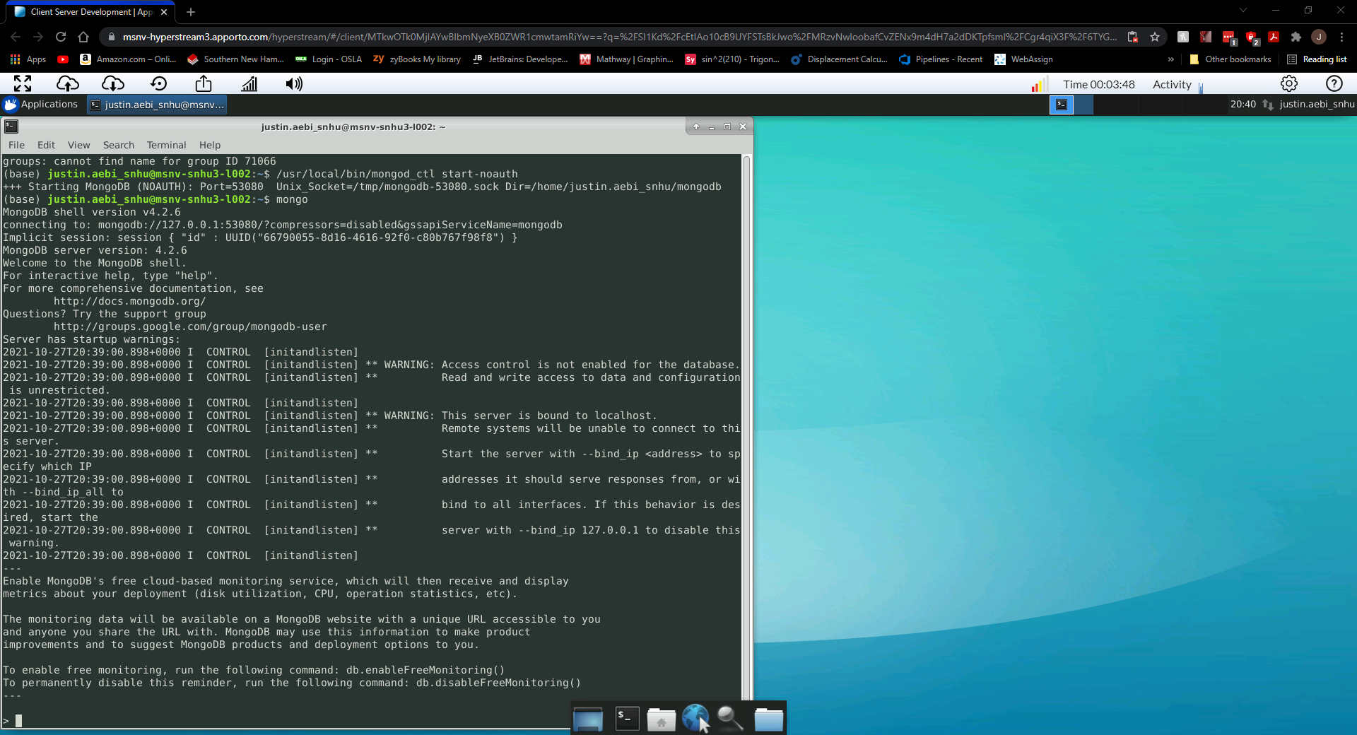

Once running make sure to note your port number you will need this for importing the files. You will then need to import the .csv files that contain your database of animals. Here is an example of this using Linux shell prompts:

Once the files have been imported go ahead and enter the mongo shell by typing: “mongo” in the Linux shell. To create a new user, use this command in the example shown below:

This will allow you admin access to the AAC database. You can then exit the mongo shell and reenter it with that user login by typing “exit” to exit and the then the second command in the following image:

Here is an example of two user logins, one being in the admin database and the other being in the AAC database.

**Using the python script tool:**

To use the scripts simply navigate to the directory where the python files are located and type in the following: “python test_script.py”

This will run the scripts and output the results to the terminal window.

Here is an example of this:

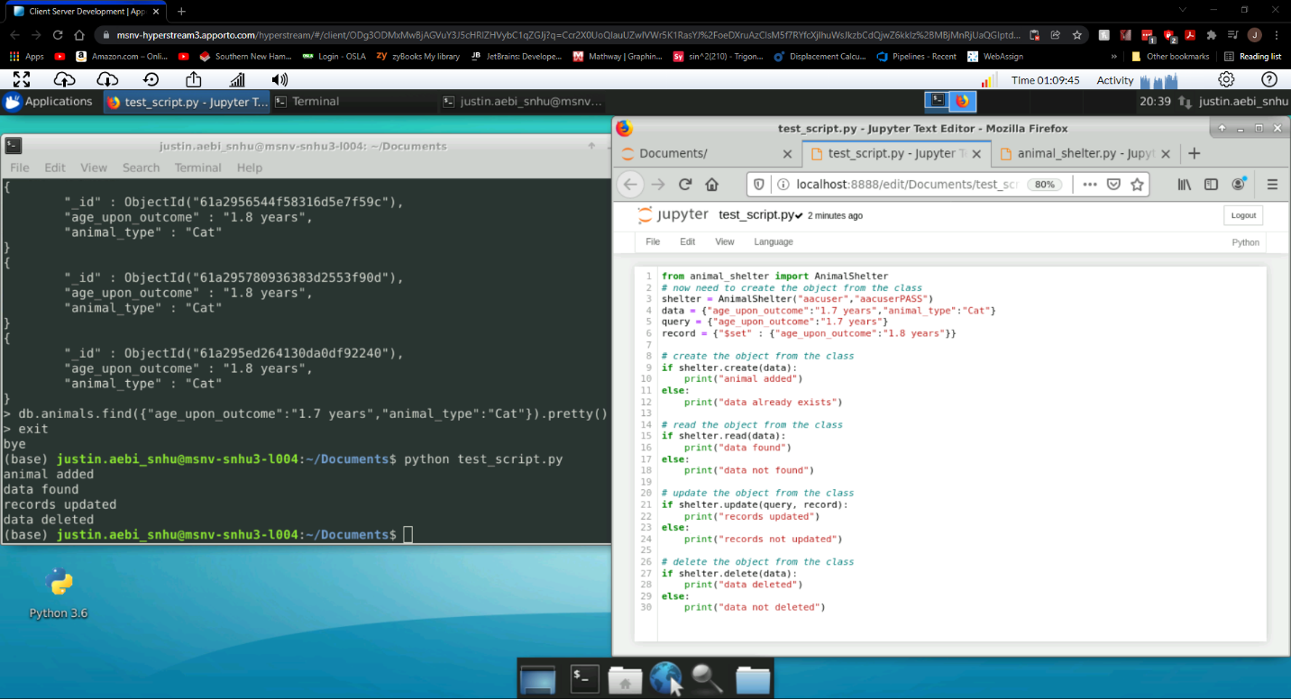

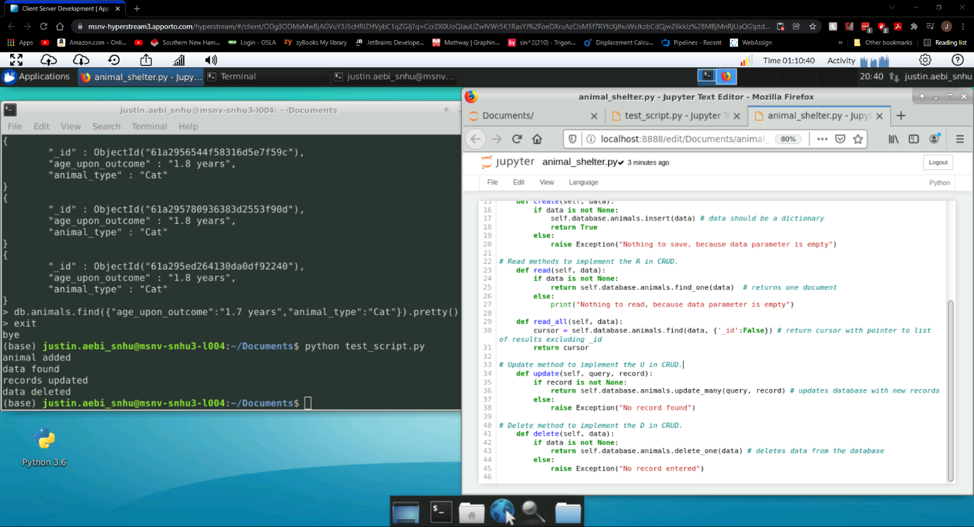

These scripts were created to create, read, update, and delete database fields for the animal shelters information that was imported. I created the create and read functions in the animal_shelter.py file by accessing the animals database and inserting and reading json file format information. These functions will allow the user to create new animals to add to the database using json format entries and handle exceptions if the data parameter is empty using mongo commands. They’re two read functions, one for finding one instance of an animal and the other for finding all entries that match the animal that will access the animals database using mongo commands to find what is needed. The update function will allow the user to change previously entered fields with new record information. The delete function will allow the user to remove and entries with the fields entered.

**Running the application:**

To run the application you must have all the required files into one location. Those are the animal_shelter.py, and the ProjectTwoDashboard.ipynb files. Once those have been placed in the same location you start by running the mongodb server. Do this by entering mongod_ctl start inside the terminal window. Once running open the Jupyter Notebook application. You should see some options similar to this:

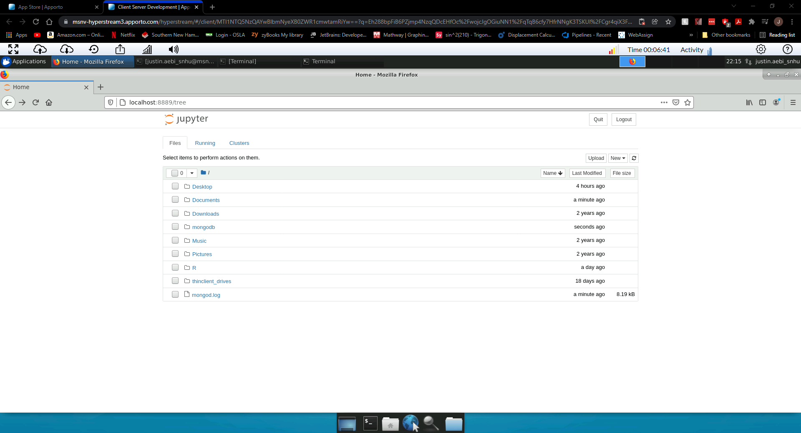

From here make sure to select the folder where the files are all located together. For me it is documents.

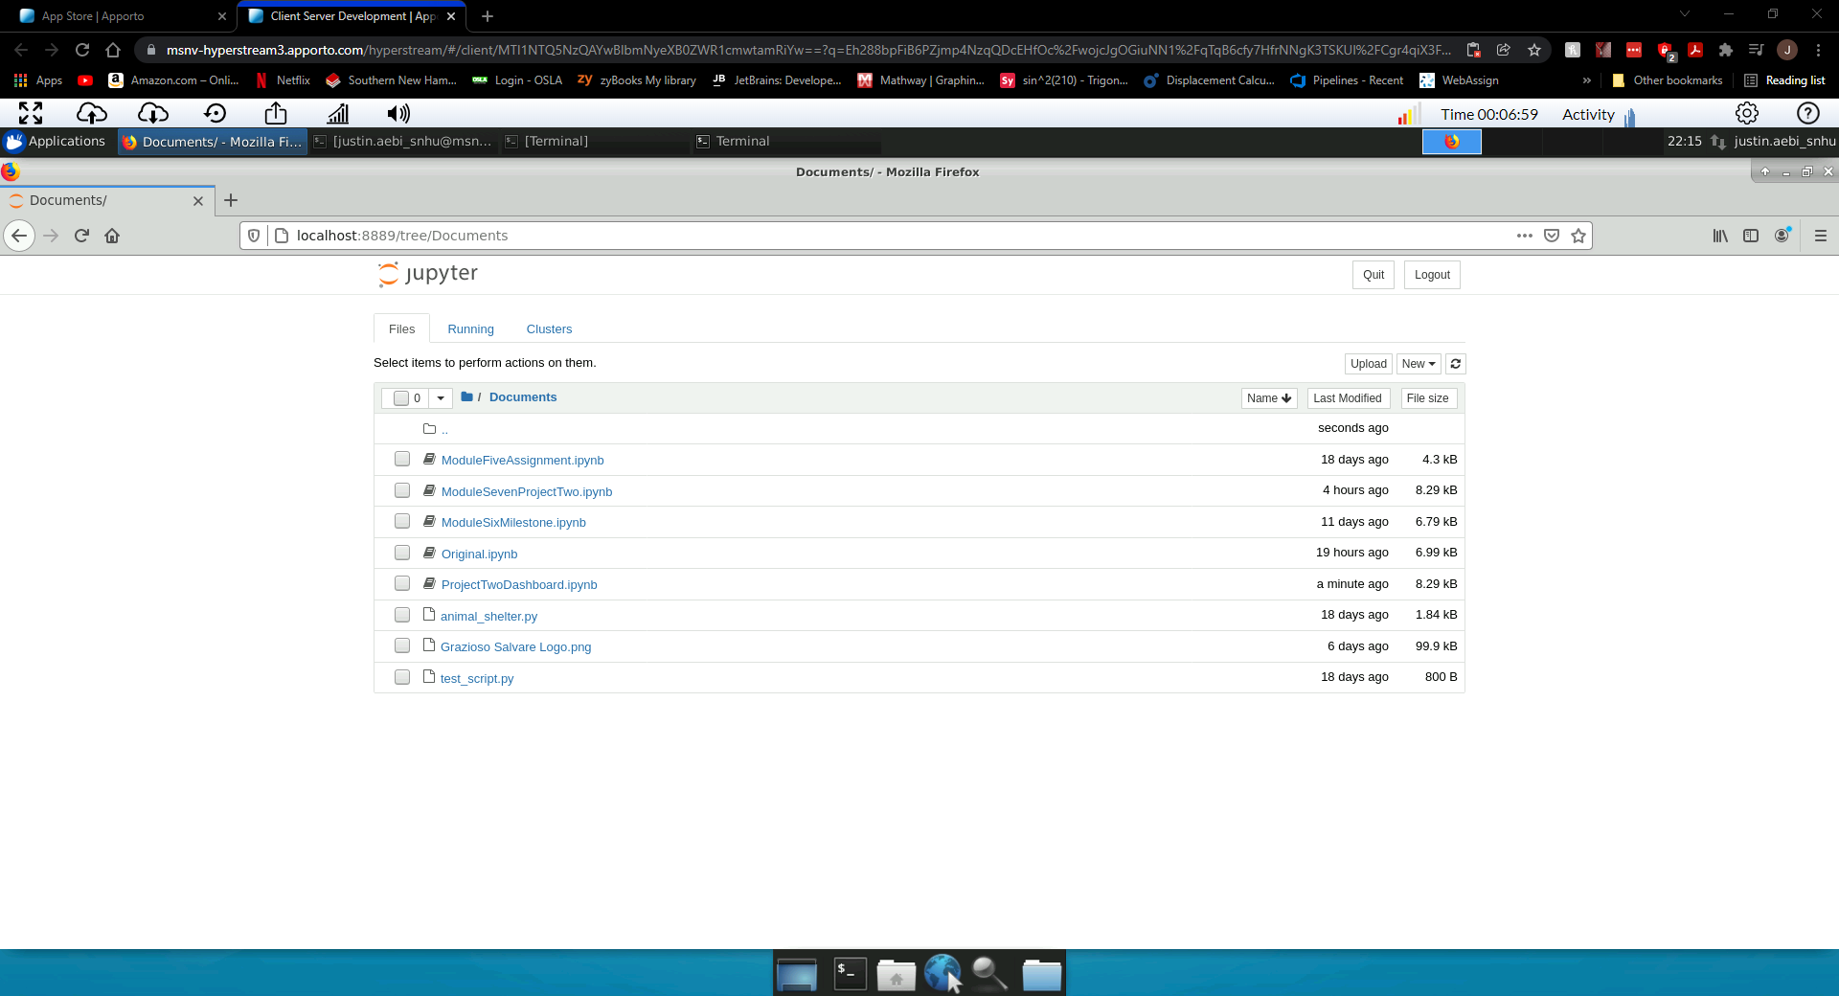

Once here, open the ProjectTwoDashboard file to open the applications code in Jupyter.

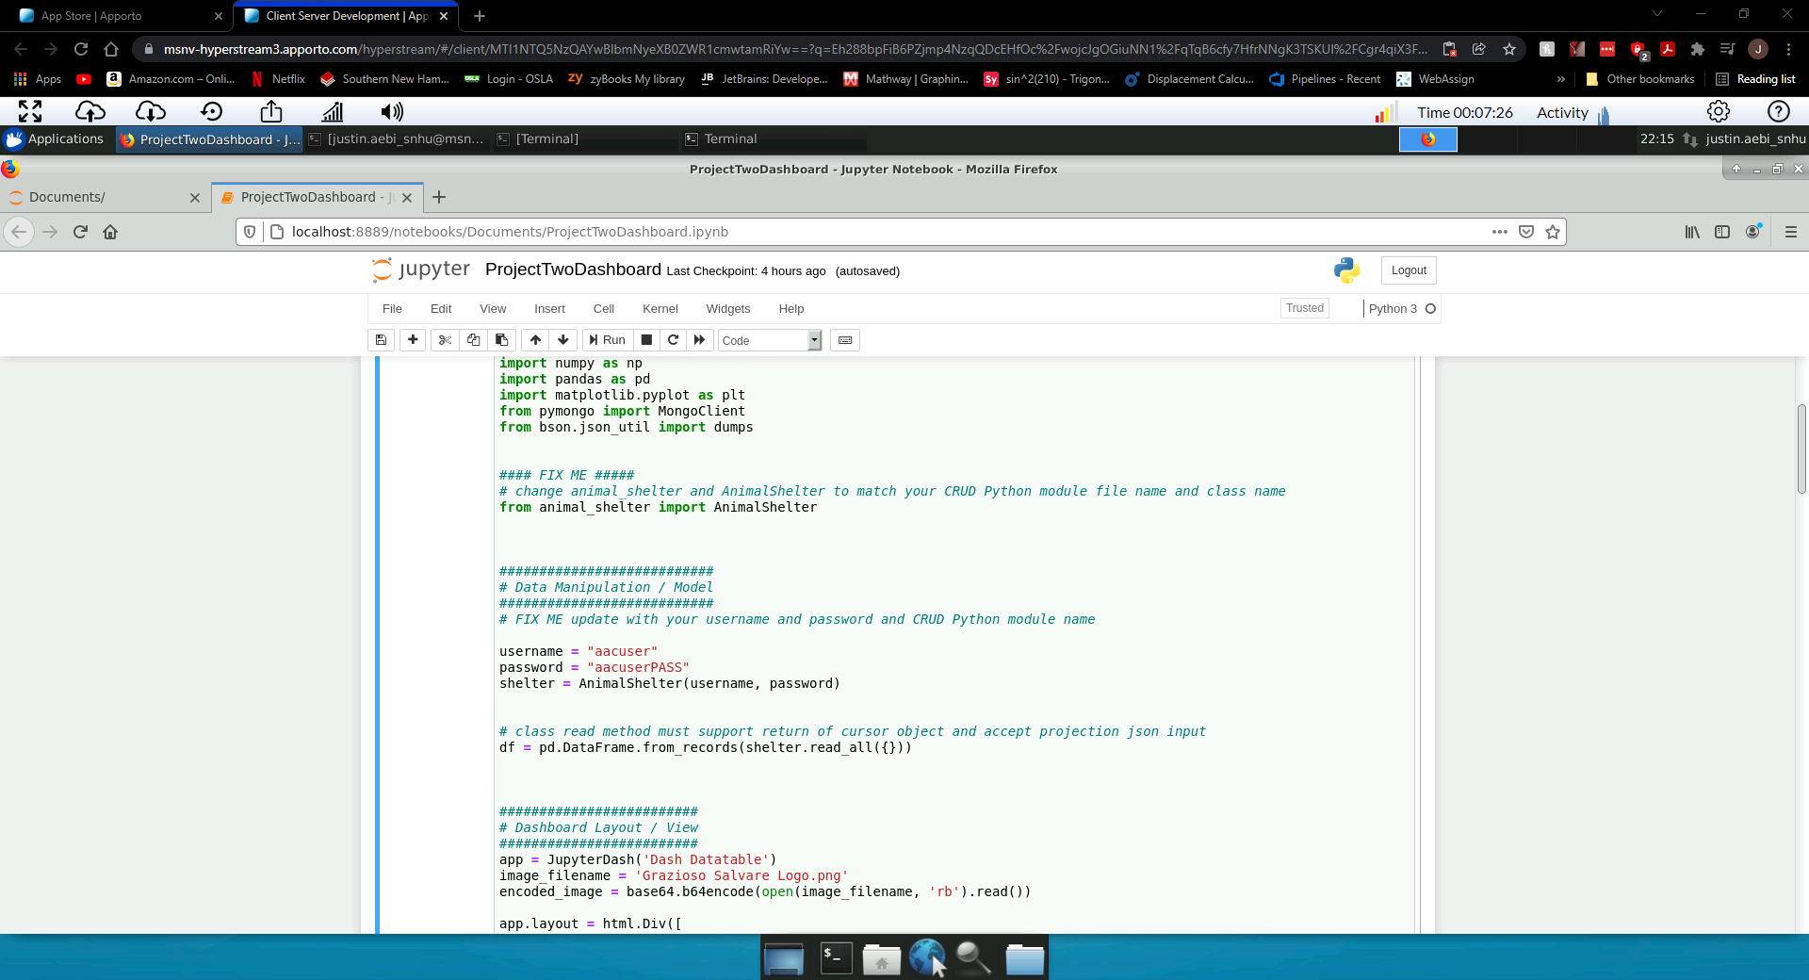

Next make sure that your username and password are correctly entered in the code. Go ahead and click on run from Jupyter.

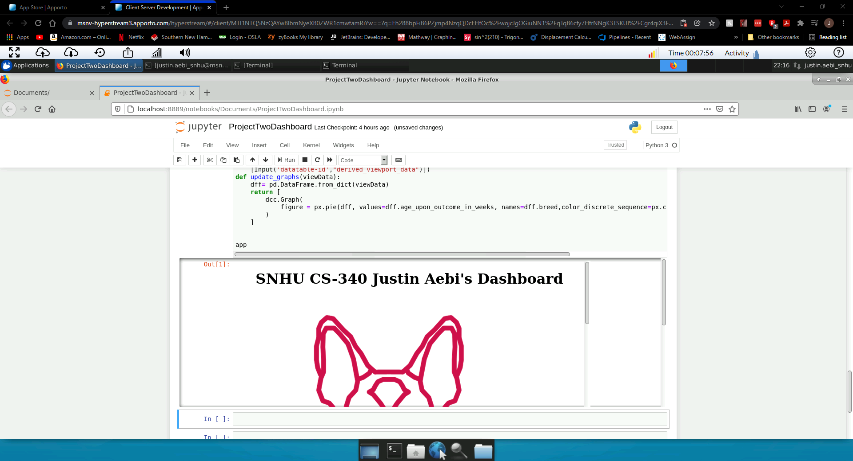

You should see the application has loaded.

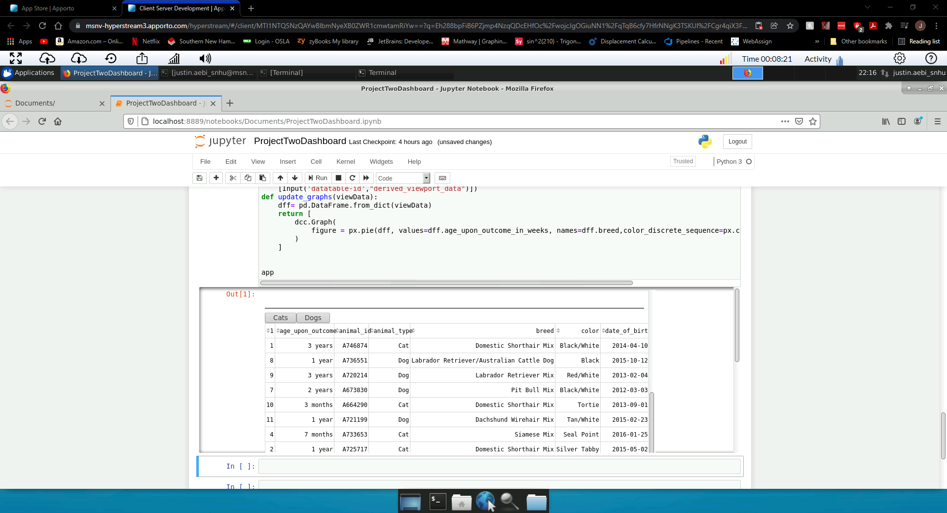

If you scroll down you will see the database loaded and displayed for you. There are even filtering options to select from to narrow down the database.

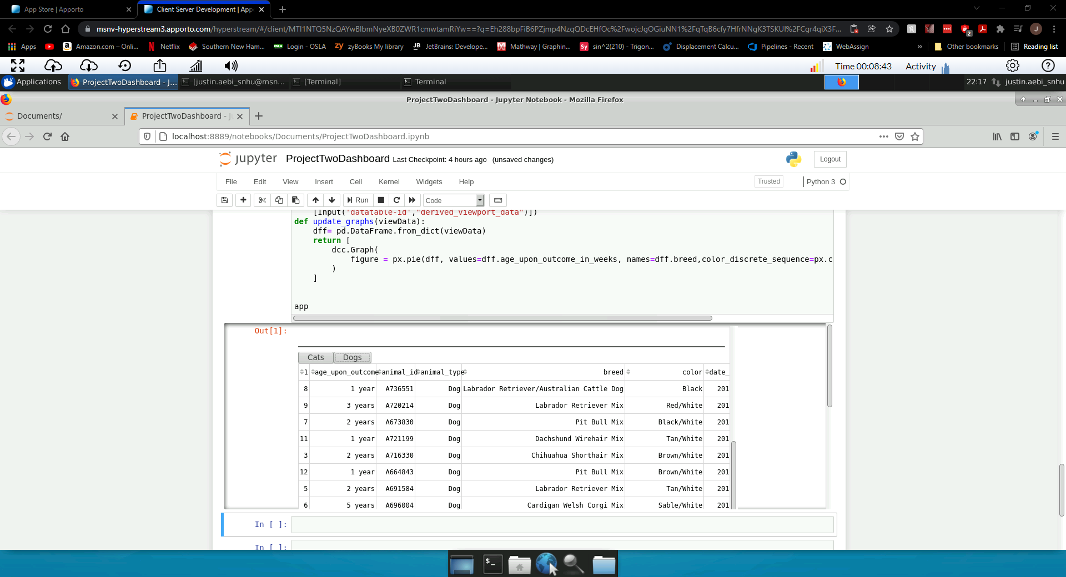

You can select Dogs or Cats to select which animals you want to view inside the data table. Clicking more than once may be necessary.

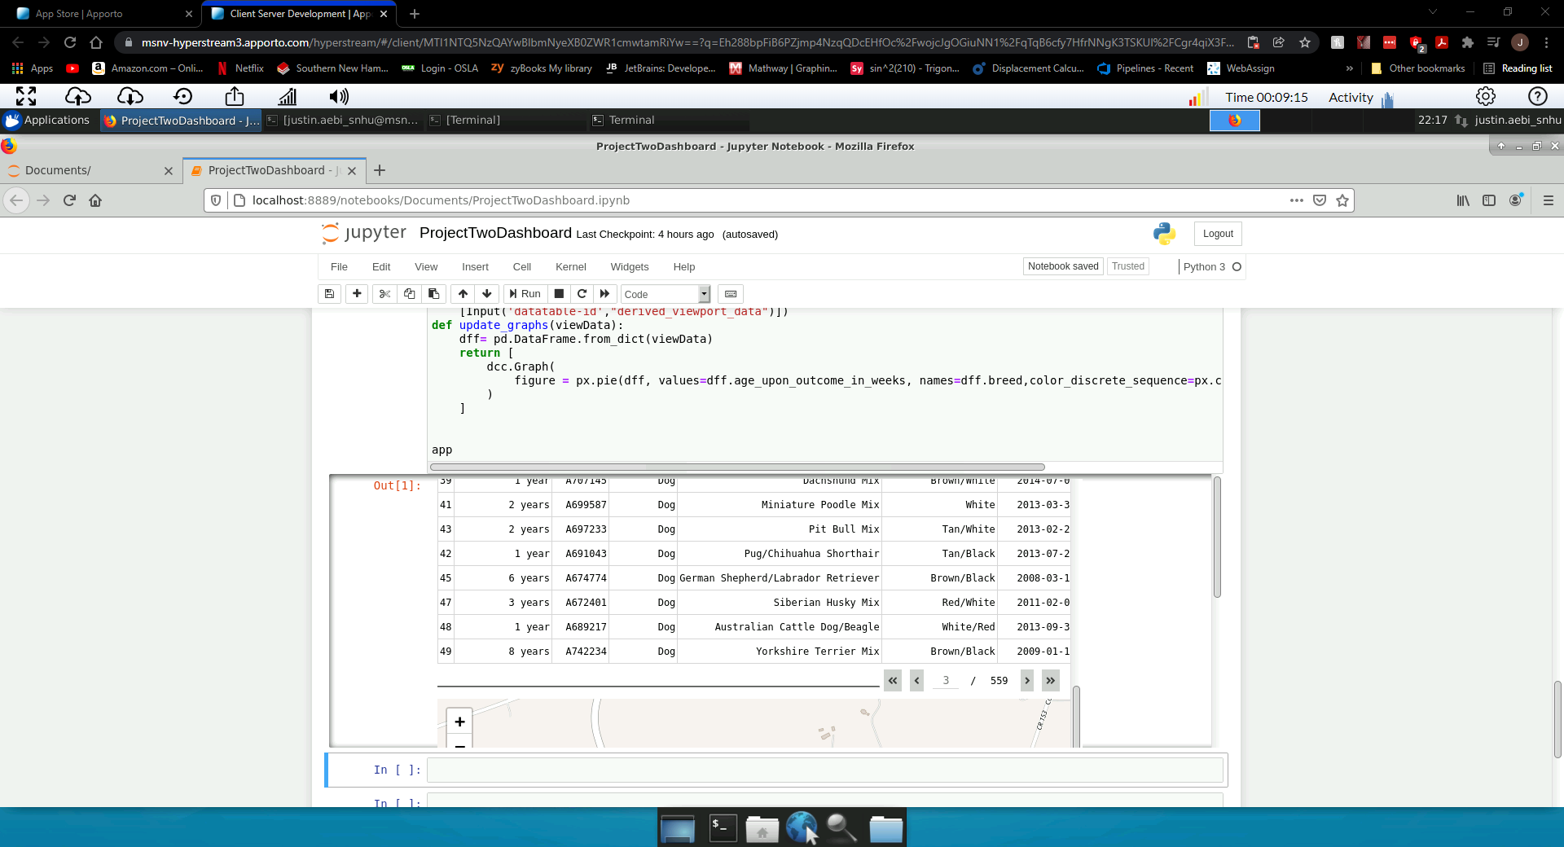

You can also chose which page of the data you would like to display. Keep in mind that the map and pie chart below will update when you make a new page selection to indicate the animals from that page.

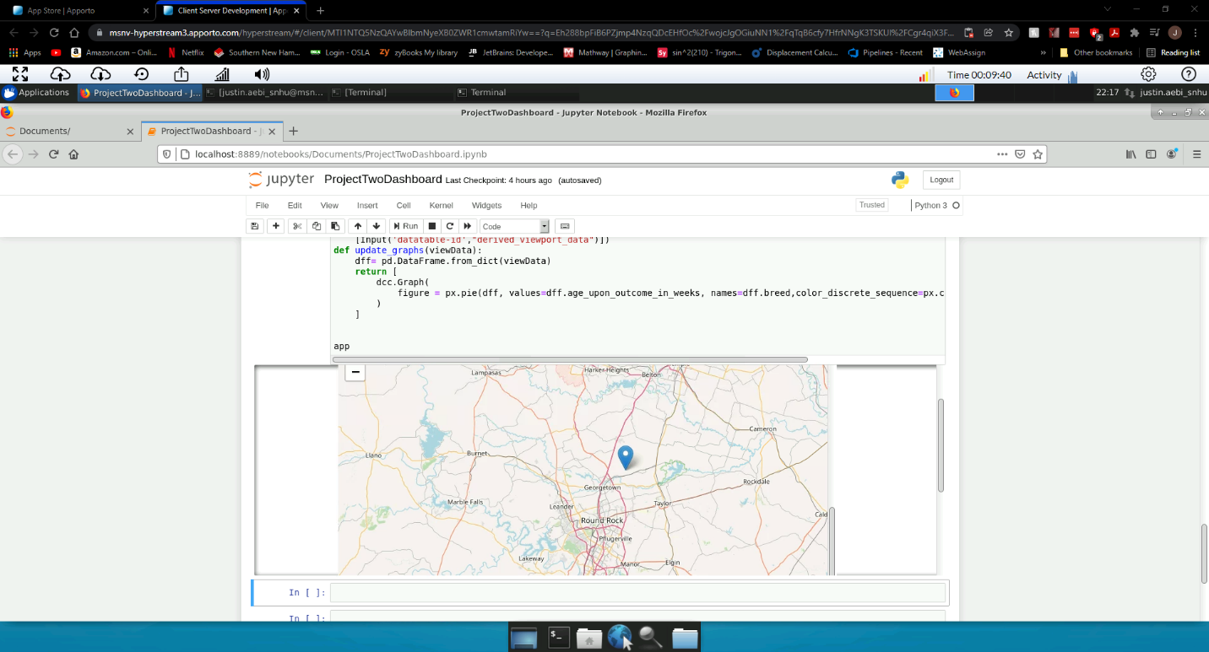

You can navigate the map and see the locations of the pets selected and they will show up with a pin icon.

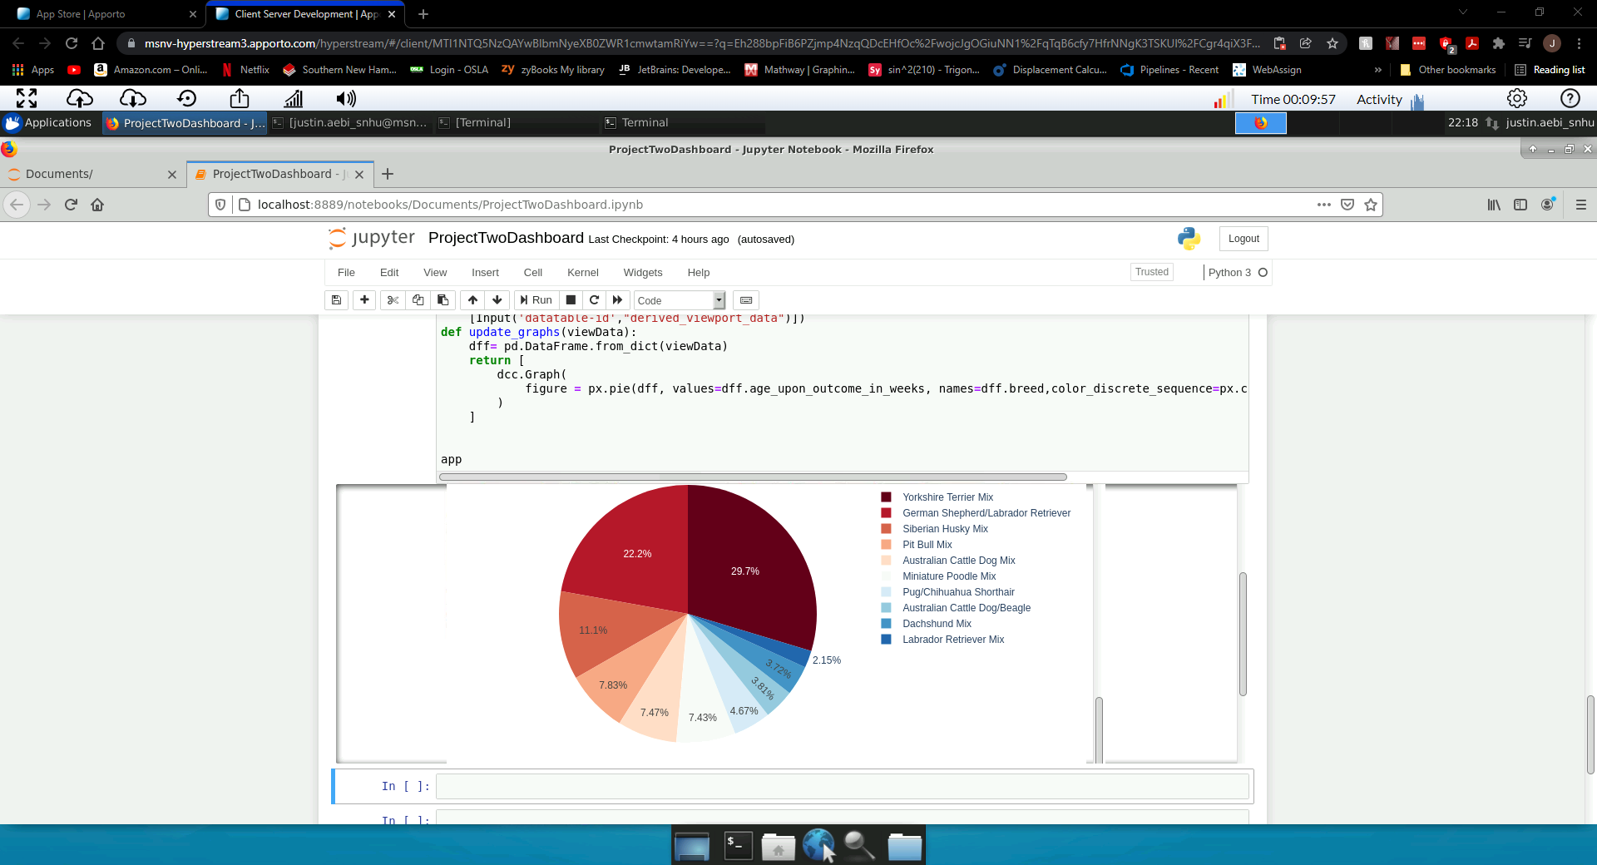

There is also a pie chart that will present the pages animals and the breed as well as the associated ag_upon_outcome_in_weeks.

## Contact

Your name: Justin Aebi